**CPSC 304 Project Cover Page**

Milestone #: 3_______

Date: 2022/2/26____________

Group Number:73 __________

| **Name** | **Student Number** | **CS Alias (Userid)** | **Preferred E-mail Address** |
| --- | --- | --- | --- |
| Yuechang Liu | 38612263 | y1g7t | lyc021202@gmail.com |
| Cong Cheng | 31070519 | v5a3b | ccheng0715@gmail.com |
| Toby Li | 45239803 | Liyt03 | litoby1203@gmail.com |

By typing our names and student numbers in the above table, we certify that the work in the attached assignment was performed solely by those whose names and student IDs are included above. (In the case of Project Milestone 0, the main purpose of this page is for you to let us know your e-mail address, and then let us assign you to a TA for your project supervisor.)

In addition, we indicate that we are fully aware of the rules and consequences of plagiarism, as set forth by the Department of Computer Science and the University of British Columbia

General

During the meeting, your project TA will be looking for the following things:

1. Team members have arrived on time. Given the fairly short duration of the meeting, we

will consider anyone who does not arrive by the start of the meeting as late.

2. Each team member has committed to the CPSC 304 provided repository at least once

prior to the start of the meeting.

3. Equal contribution to the discussion by all group members.

4. Willingness to participate in the discussion.

Feel free to discuss any questions/concerns you have with your TA. If you are uncomfortable

with discussing your concerns publicly, you can also email your TA (contact information can be

found on Canvas). If your TA does not reply within 2-3 business days, contact your instructor.

If the check in meeting starts late, no extra time will be given. In cases where the meeting starts

late because of an issue on the part of the teaching team, the meeting will run for the

scheduled length of time.

You may wish to update your deliverables for this milestone after meeting with your TA. We

ask that you do not do so until the milestone grades have come out. This will help ensure that

your TA looks at the correct commit when grading and it will speed up the process of grading.

Graphical User Interface (GUI)

Your project will require a front end (i.e., a GUI) for the user to interact with the database.

When designing the GUI, think of it from the perspective of a user who is unfamiliar with

Computer Science. The GUI should be user friendly and relevant to whatever topic your group

has chosen. For example, "Create New Account" could be the name of a button that runs an

“Insert” query and would be more appropriate than “Insert Query Button”.

We expect you to produce a simple but adequate interface; it doesn’t have to be fancy.

You should not be creating a text-based user interface (e.g., tutorial 6). The user should not

be typing in a SQL statement at any point in the process.

You cannot use a GUI-generating tool (such as Java Swing UI Builder).

Deliverables

Your deliverables should be committed to the CPSC 304 provided repository at least two

business days prior to the meeting with your TA. For a specific definition of what two business

days ahead of schedule means, see the syllabus.

1. A brief (~2-3 sentences) summary of your project. Many of your TAs are managing

multiple projects so this will help them remember details about your project. You can

reuse the summary from milestone 2.

This database will provide information about professional soccer. As soccer players, they can use this database to decide which team they want to join. As the manager of soccer clubs, they can choose which player they want to buy. And as sponsors, they can decide if the team is worth sponsoring.

2. Timeline and task breakdown/assignment: The breakdown should be at a level of detail

that demonstrates that the group has spent time meaningfully considering what there is

left to do. Note that we are not asking you to predict every single possible task that you

will need to do. We want to see that the group understands the scope of what is left to

do and is prepared to accomplish the remaining tasks in a reasonable manner.

Each task should be specifically assigned to a group member (or combination of group

members). It is in your best interest to be as explicit as possible about who will work on

what. In the event that there is a dispute between group members, this is one of the

first things the course staff will look at when evaluating the situation. If it is clear to us

what has been agreed on, it will speed up the process of conflict resolution.

Unless otherwise stated, it is assumed that all group members will work equally on the

project. This does not mean that everyone needs to work on each task together. This

means that the overall division of the work is equal. If this is not the case, state the work

percentage breakdown for each member. This will serve as a written acknowledgement

between all group members that there will be an uneven distribution of work. The

member who does not do their fair share of work will have a penalty applied to their

final project grade.

While each member is not expected to know about every single line of code in the

project, it is expected that all members can talk about the overall architecture of the

project.

The timeline should contain enough detail for your project mentor to determine that

you understand that you need to produce a GUI for your full project.

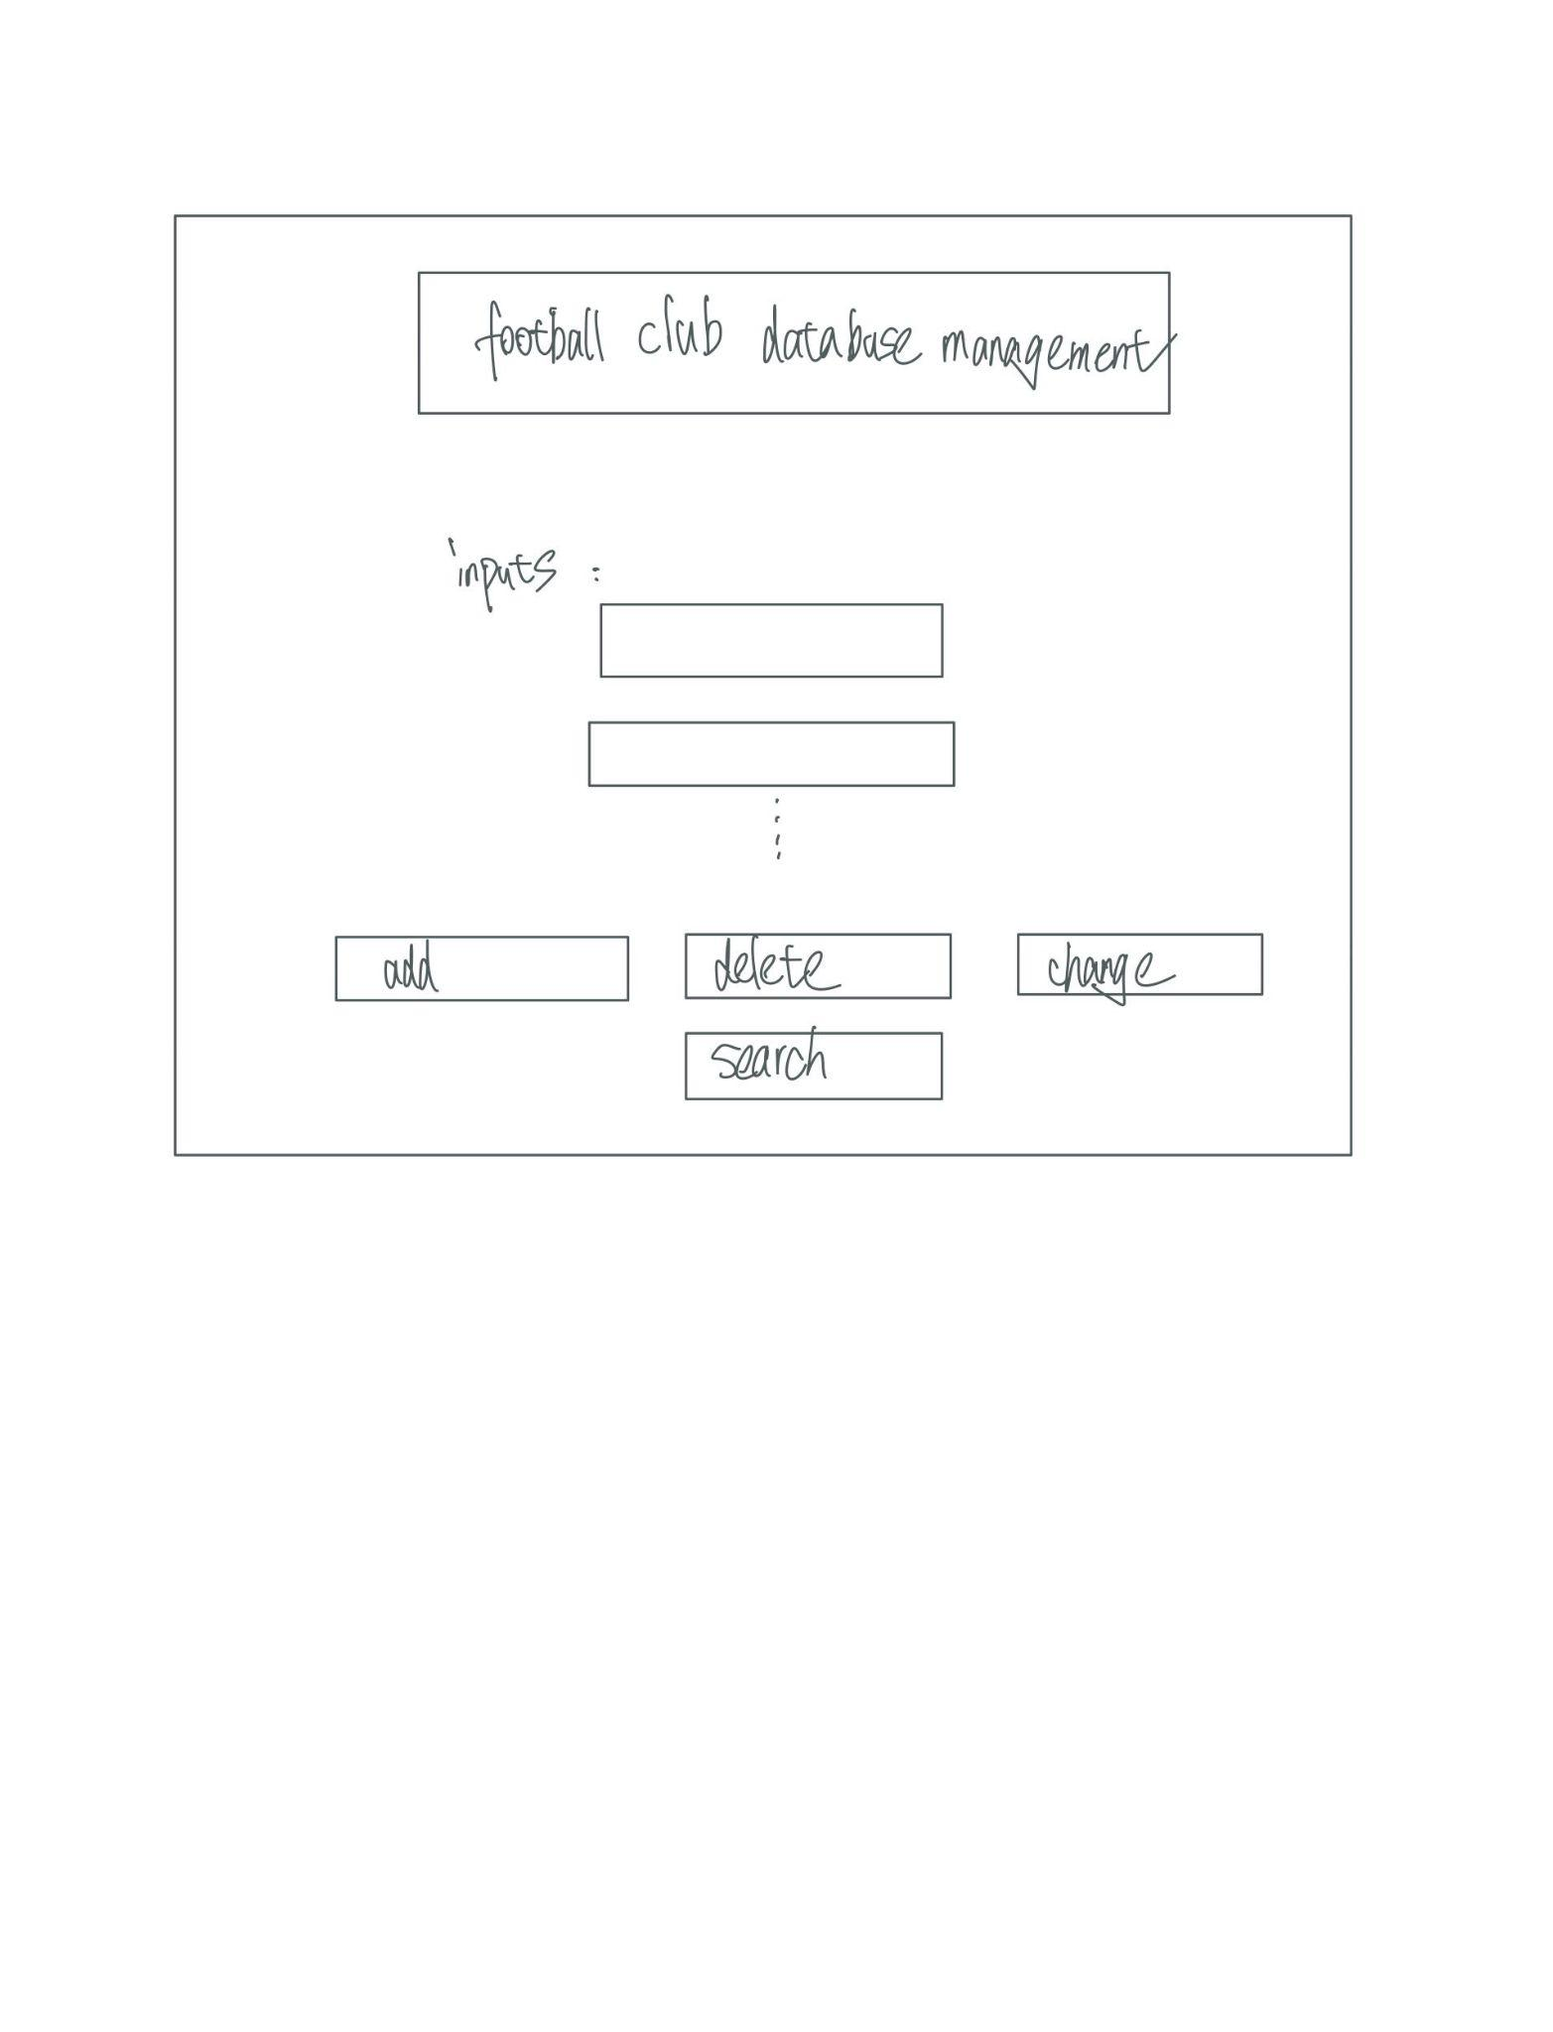

Timeline:

March 21st: Code the basic structures of the webpage(first page: edit/search, second page: data viewing) using HTML, write down all the functions (not the whole code, just comments)

28th: implement all functions of database(including add, delete, search, view, replace…)

31st: Finish the database viewing page

Apr 3rd: Finish the whole design of the project by adding detailed css

Apr 5th: Final check and handin

Divide the tasks:

All 3 members will take part in writing both frontend and backend( end-to-end). Specifically dividing the whole project into different inquiries. Each person is responsible for creating their bit of the GUI and ensuring that it is functional/can properly communicate with the database. We will individually finish the design of some of the buttons, input bars, and Text files.

3. The deliverables from milestones 1 and 2 have been added to the repository.

4. Each group member has made a commit to the repository. The commits do not have to

be code related. For example, one group member can commit the milestone 1

deliverables, another the milestone 2 deliverables, and the third member the milestone

3 timeline.

During the meeting, your project mentor may ask each group member to demonstrate

that they are able to make a commit. It is in your best interest to get everything set up

now. In the event of a group dispute or disagreement over the level of contribution

made by each member, we will be looking at the commit history. Git is an essential skill

and this is a great way to get some practice at using it in a group context.

See the milestone 3 assignment on Canvas for the rubric. Refer to the syllabus for information

on late submission/penalty rules.